ECO 330: Problem Set 1
Name:
Student ID:
Problem 1
1.a) Need to report all the numbers in table below. Don’t have to necessarily report them in a table.
 | Mean | Highest | Lowest | Percent under 15000 | 80/20 Ratio | Gini
Initial Economy  (everybody has 15000) | ## | ## | ## | ## | ## | ##
Post Simulation  Economy (after 45 years) | ## | ## | ## | ## | ## | ##

Actual value of 80/20 ratio was ###
Actual value of Gini was ###
1.b) Gini coefficient ________ (increases/decreases/stays the same) to ###
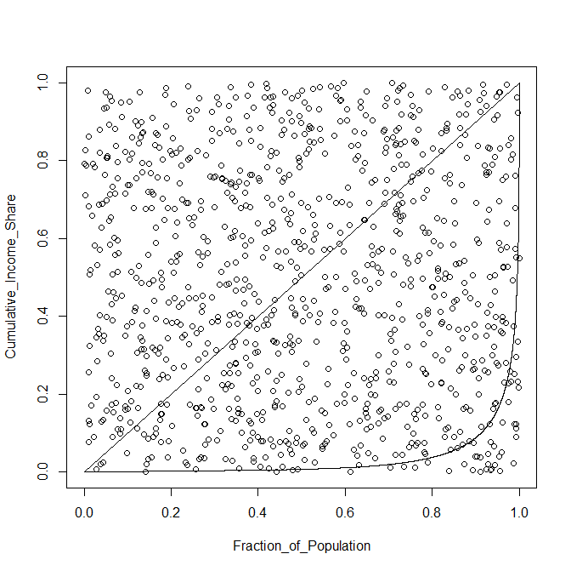
1.c) Copy graph from R to Word $→$
(right click on graph in R and select “Copy as bitmap” then paste into Word)
[Write something about Monte Carlo Integration and how we use it to estimate the area under the Lorenz Curve]

1.d) [Write something about what this simulation says about luck as a potential source of income inequality.]
[Write something that’s missing in our simulation that is important for inequality in the actual world.]

Challenge Question
Marginal tax rate needs to be #### percent on income over $50,000.
Gini coefficient ________ (increases/decreases/stays the same) to ### after implementing the tax.
Copy and Paste code/work to end of problem set if you attempt challenge question.
Problem 2
2.a) See Graph. [Don’t need to put anything here. Will grade it based on graph in 2.b.]
2.b) Copy and paste the U.S. growth accounting decomposition graph below. 2.a is graded on if the lines look correct, 2.b is graded on if your graph looks professional (see my tips)
None of the graphs posted in this template are the correct graphs, but they are similar to the correct graphs (e.g. this is for Mexico for the U.S.)
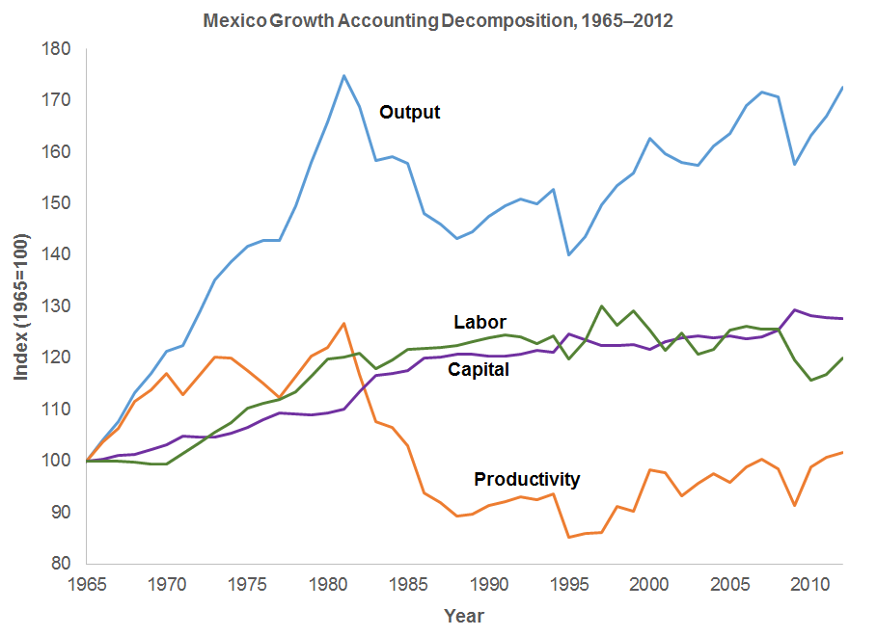
2.c) Most important component for growth in GDP per WAP is the __________ component (remember we have three components that decompose output/GDP per WAP into)
2.d) [Write about some things that affect TFP in the data. Lots of examples exist]
2.e) [Write about what happened to the labor supply component in the quarterly growth accounting decomposition]
[Write about how this affected GDP according to our decomposition.]

Problem 3
3.a) Post the graph with a linear scale. Make it look professional.
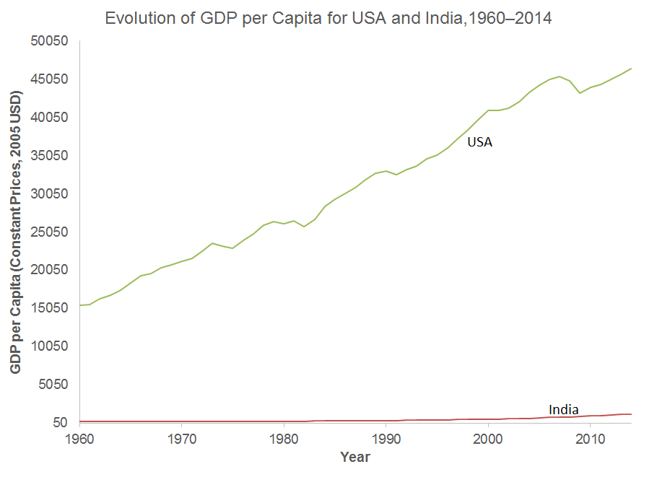
3.b) [Whatever you think when you look at the graph. Might look like they grow about the same speed, or might look like one looks faster. Answer the question and you get this question correct.]

3.c) Post the graph with a log base 2 scale. Make it look professional.
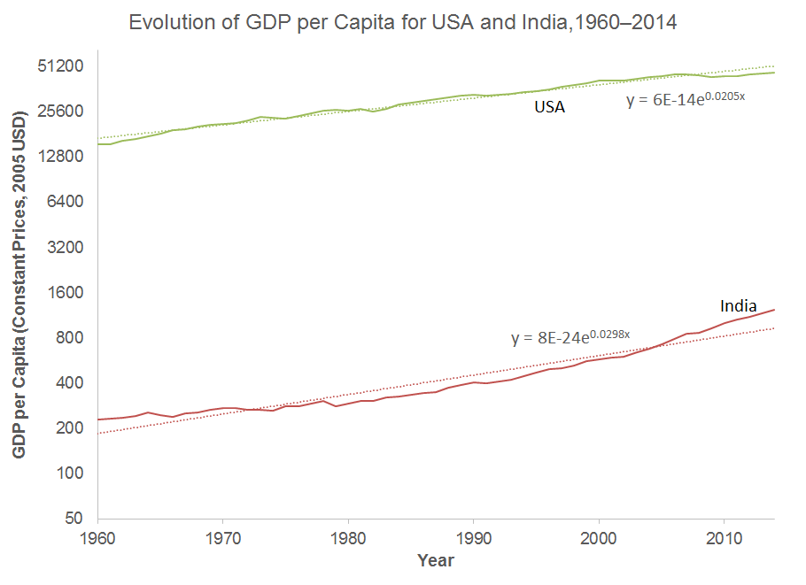
3.d) This graph shows us that _______ is growing faster. (From the graph in 3.c it should be obvious which country is growing faster)
3.e) Equation for trendline for Mexico is
[Copy Trendline Equation from Excel]
This means the annualized growth rate of Mexico is approximately ### percent per year
Equation for trendline for China is
[Copy Trendline Equation from Excel]
This means the annualized growth rate of Mexico is approximately ### percent per year

